Nota
EVALUACIÓN FINAL DEFINITIVA

ALUMNO (S):

_________________________
_________________________
_________________________
_________________________

________________________________________________________________________________
- Redacte UN TEXTO EXPOSITIVO. Tome en cuenta las siguientes consideraciones:

- Ceñirse a las estructuras mostradas en clase.
- Busque la información correspondiente basándose en la elección del tema.
- Tome en cuenta la rúbrica de evaluación FINAL.
- Elegir uno de estos temas:

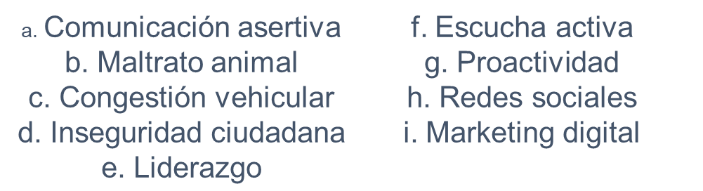

TÍTULO: ________________________________________________________

INTRODUCCIÓN (TIPO): ________________________________
Integrante: ________________________________

________________________________________________________________________________________________________________________________________________________________________________________________________________________________________________________________________________________________________________________________________________________________________________________________________________________________________________________________________________________________________________________________________________________________________
PÁRRAFO DE DESARROLLO 1
Integrante: ________________________________

______________________________________________________________________________________________________________________________________________________________________________________________________________________________________________________________________________________________________________________________________________________________________________________________________________________________
____________________________________________________________________________________________________________________________________________________________________________________________________________________________________________________________________________________

PÁRRAFO DE DESARROLLO 2
Integrante: ________________________________

_________________________________________________________________________________________________________________________________________________________________________________________________________________________________________________________________________________________________________________________________________________________
____________________________________________________________________________________________________________________________________________________________________________________________________________________________________________________________________________________

CONCLUSIÓN (TIPO): ________________________________
Integrante: ________________________________

____________________________________________________________________________________________________________________________________________________________________________________________________________________________________________________________________________________

FUENTES :
- ______________________________________________________________________________________________________________________________________
- ______________________________________________________________________________________________________________________________________

